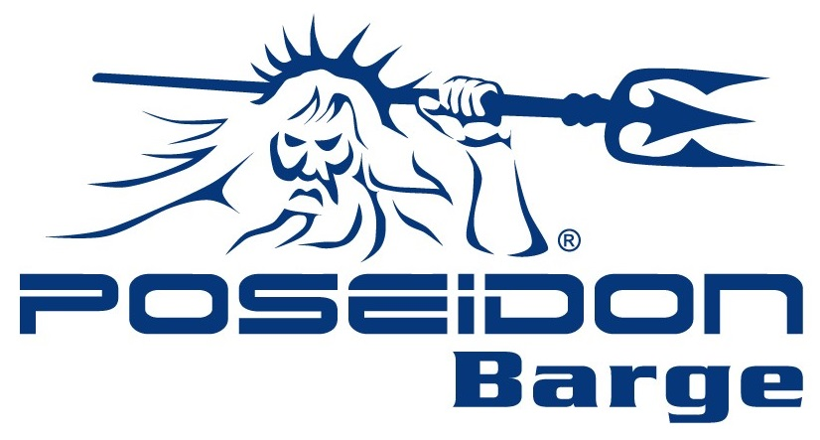

## **Supplier Quality Assurance Manual**

**Poseidon Barge**

725 E Parr Road & 750 E Parr Road

Berne, Indiana 46711

USA

**Suppliers:**

#### Poseidon Barge, LTD is committed to supplying high quality, reliable and cost-effective portable sectional barges in a timely manner to our customers. Therefore, it is the goal of Poseidon Barge to form a partnership with its suppliers to ensure:

* Quality materials
* On-time delivery, and
* On-going price competitiveness throughout the supply chain.

Poseidon’s Quality Policy can be found on our web-site (<https://www.poseidonbarge.com/poseidon-quality-policy/>).

This Supplier Quality Assurance Manual is intended to ensure that all suppliers adhere to the quality, purchasing and delivery requirements of Poseidon Barge, LTD. It is based on, but not limited to, the internal operating systems of Poseidon Barge and the quality system requirements of ISO 9001:2015 and is intended to serve as a link between Poseidon Barge and our suppliers, both existing and potential.

Furthermore, the requirements of this manual describe a few of the minimum requirements that are placed on the supplier’s quality management system. It is designed to supplement the fundamental technical and organizational conditions that govern all deliveries and services and not replace or amend the terms and conditions specifically noted on purchase orders, engineering drawings, prints and/or specifications, agreements, or contracts.

We appreciate your cooperation, and if you have any questions please send them to [purchasing@poseidonbarge.com](mailto:purchasing@poseidonbarge.com).

**This forms can be found on the Poseidon Barge web site (**[**http://poseidonbarge.com**](http://poseidonbarge.com)**).**

TABLE OF CONTENTS

Quality System Requirements 4

**Supplier Approval Requirements** 4

Approved Supplier 5

**Evaluation and** **Escalation Process** 5

**Request for Quote** 6

Purchase Order 7

**Request for Change** 7

Change Point Control 9

Supplier Change Identification 10

**Evidence of Material Properties** 10

**Receiving Inspection, Containment and Corrective Action** 11

**Poseidon Corporation Owned Property** 11

##### Quality Systems Requirements

Poseidon Barge is a manufacturer of portable sectional barges and welded assemblies used in bridge construction, general marine construction, dredging, and other construction projects. Our aim is to enhance customer satisfaction through effective application of a quality management system with a focus on continual improvement and assuring the conformance of supplied product to our customer’s requirements and/or regulatory requirements.

Our suppliers of related material and components should be registered by an accredited 3rd party certification organization to the current ISO 9001 standard. Otherwise, a quality system must be implemented and verified. Upon review of Self-Evaluation (SUP-002), a Poseidon Barge representative may elect to schedule a supplier audit to assure all requirements are met.

No business can be placed with a new supplier prior to them being placed on our Approved Supplier List.

##### Supplier Approval Requirements

Before becoming a supplier of components or material, the Supplier Evaluation Profile (SUP-002) must be completed and returned. Then, the Purchasing Manager will complete the Supplier Risk Assessment (SUP-004), pending approval of the Quality Manager. Once accepted your company will be added to our Approved Supplier List. The acceptance process involves the determination that your company meets the following criteria:

1. A Quality Management System is in place. This can be shown by:

* Certification to the current ISO9001 standard by an accredited third-party certification body, or
* Being a customer-specified supplier of one or more of our customers for the specific component or material required and/or audit by a Poseidon Barge representative to ensure compliance to the customer requirements.
* A deviation to the Supplier Approval Process may be granted through a formal process if necessary to procure material in order to maintain adequate supply for operations. In this event, form SUP-005 Material Deviation Approval Form will be used to document this deviation.

1. Test reports and certifications can be supplied (as required).

Copies of documents required must be supplied upon request.

##### Approved Supplier

To maintain Approved Supplier status, a supplier is one who has met the requirements criteria must also:

1. Be fully responsible for all aspects of controlling quality and delivery of product supplied. This includes but is not limited to the product:

* Meeting the requirements of the purchase order, including the product quality expectations and requirements specified in this manual.

In addition, the supplied product must be:

* Clearly labeled,
* Packaged to prevent damage during transit, and
* Delivered on time

1. Ensure that all certifications and other required documentation is available,
2. Be responsible for ensuring that any sub-supplier understand and meet Poseidon Barge requirements and expectations.

**Evaluation and** **Escalation P****rocess**

Poseidon Barge evaluates supplier performance annually by means of a rating system.   The supplier evaluation details supplier performance in Delivery, and Quality.  In the event of an unsatisfactory rating, the supplier status may be downgraded from “Approved” to “Needs Re-evaluated” or the worst case of “Disqualified”.  Once graded “Disqualified” a supplier will be blocked from quoting on new business. Suppliers failing to achieve and maintain the “Approved” status may be required to develop a plan to correct performance.

If a supplier feels that their performance has deteriorated, it is their responsibility to confirm their rating by contacting the Poseidon Barge Purchasing Department.

The change of the status of a Supplier and escalation may include:

1. Performance measurements which fail to meet On-time delivery, and quality levels as determined by Poseidon Barge.
2. Failure to submit corrective action reports,

Annual performance evaluations will be comprised of:

* Delivery (on-time) - On-time delivery rating is based on the number of Late shipments on average per month received within the specified time-period window. This window is the expected delivery date. Any delivery after this date will be counted as NOT on-time. Scores range from 0 to 5. A 5 correlates to all deliveries being on-time and a 0 equates to 5 or more late shipments in a month.
* Quality (Non-conformances) – Nonconformances (NCs) are counted as any defect to quality or packaging of product that results in an adverse effect to Poseidon. Scores range from 0 to 5. A 5 correlates to all no NCs and 0 equates to 5 or more NCs in a month.
* CAR (Corrective Action Report) Responses – Supplier will be reviewed upon response time and completeness of CARs. Scores are 0 - Does not complete CAR, 3 - Late Response & Complete, and 5 - On-Time & Complete. When no CARs were requested, result will be Not Applicable (N/A)

Supplier Evaluation is the average score of Delivery, Quality and CAR Response, with results below:

|  |  |  |
| --- | --- | --- |
| **Score** | **Average Score Results** | **Average Score Meaning** |
| 5 | Approved | Supplier Maintains Excellent Performance |
| 4 | Approved | Supplier Maintains Satisfactory Performance |
| 3 | Needs Re-Evaluated | Supplier Needs Re-evaluated in 6 months |
| 2 | Needs Re-Evaluated | Supplier Needs Re-evaluated in 6 months |
| 1 | Disqualified | Supplier Needs Disqualified |
| 0 | Disqualified | Supplier Needs Disqualified |

**Request for Quote (RFQ)**

A request for quote will be solicited by Poseidon Barge. This will be the only quote that will be considered for acceptance. The quote must:

* Be returned/delivered within 2 working days, unless an exception is granted,
* Be complete to print and specification requirements, and
* Offer competitive pricing.

The Supplier is responsible for:

* Understanding all the parameters of producing and supplying the product,
* Providing value added recommendations that affect production or shipping,
* Providing technical support, and
* Warranty costs directly related to the product, through the end-of life of the product.

If a quote has been accepted, a supplier may be required to submit a feasibility and **project timeline. These documents become a method of determining if any special risks have been identified by the supplier which would necessitate a change in the project timing, or other considerations**. **These documents are completed on the supplier’s internal forms.**

**Purchase Order (PO)**

#### All purchase orders will include:

* P.O. Number,
* Product being purchased **(**including but not limited to specific part number with revision level, process type and specification, and requirements for testing or approval, et al.),
* Quantity being ordered (or service required if quantity not applicable),
* Price, and
* Other contractual agreements, as required.

The general terms and conditions that comprise the supplier’s acceptance of the Purchase order can be found on the Poseidon Barge website ([**http://poseidonbarge.com**](http://poseidonbarge.com)).

Cancellation of a purchase order can be executed based upon the performance of the supplier, pricing issues, change in ownership, or bankruptcy. Should a supplier receive a cancellation notice, they shall have two (2) weeks to notify Poseidon Barge (through the Purchasing Department) in writing of any inventory for which they feel is the responsibility of Poseidon Barge. Failure to provide the written response will result in the supplier forfeiting any future claim associated with the PO defined by the cancellation notice.

**Receiving inspection, containment and corrective action requirements**

To verify that shipments are defect free, Poseidon Barge may choose a number of methods to verify conformance which include:

* Analysis of the statistical data received,
* Evaluation of Certificates of Analysis (CofA) received,
* Evaluation by an independent laboratory,
* Inspection and/or testing of quality characteristics by random sampling with a c=0 acceptance criteria or 100% inspection, or
* Any agreed upon method.

In the event that a shipment is rejected, whether at time of receipt or during processing, the shipment will be quarantined, and the supplier will be contacted. At this point:

* a concession (deviation) can be issued for use of the material, with any additional costs associated with the use debited to the supplier, or
* the material or product returned for replacement, or
* the material or parts be sorted with the costs associated with the sort and discarded material/parts debited to the supplier.

Additionally, a supplier corrective action report (SCAR) may be issued which will require a structured investigation of the nonconformity and corresponding documentation reported to Poseidon Barge of the proposed corrective action to prevent recurrence.

An interim response submitted via e-mail is required within two (2) work days and the completed response, which address permanent corrective actions within two (2) weeks (14 calendar days).

**Poseidon Barge Owned Property**

Any Poseidon Barge property that is in a supplier’s control; such as, tooling, containers or intellectual property that is provided shall be identified and protected. If any become lost, damaged or found to have been rendered unusable, it is the responsibility of the supplier to maintain records and notify Poseidon Barge as soon as possible after the event was discovered.

**References**

* (Ref. QSP-8.4 Control of External Provision)
* SUP-002 Supplier Evaluation Profile
* SUP-004 Supplier Risk Assessment
* SUP-005 Material Deviation Approval Form

**Document Change Summary**

|  |  |  |  |
| --- | --- | --- | --- |
| Revision | Revise Date | Author | Description |
| 0 | 8/19/20 | G. Cox | New Document |
| 1 | 8/18/21 | T. Fullenkamp | Highlighted in Yellow in Supplier Approval Requirements section |
| 2 | 7/3/24 | T. Fullenkamp | Removed items in Change request as they were not pertinent |